**TABLEAU CALCULATIONS & EXPRESSIONS**

**BASIC CALCULATED FIELDS**

**Concatenation**

Employee Full Name

[Last Name] + ', ' + [First Name]

**Average Unit Profit**

AVG([Unit Price]) - AVG([Total Product Cost])

**Sign of Profit**

IF SUM([Proft]) >0

THEN “positive”

ELSE “negative”

END

**IF ELSEIF**

IF SUM([Quantity]) >10

THEN “A Lot”

ELSEIF SUM([Quantity]) >5

THEN “Some”

ELSE “Not Many”

END

**AGGREGATE CALCULATED FIELD**

**Segment Sales**

This returns an error “Cannot mix aggregate and non-aggregate in IF statement

IF [Segment] = “Corporate”

THEN AVG([Sales])

ELSE MEDIAN(Sales)

END

We need to wrap the Segment in ATTR. ATTR Summarizes the data for each segment. Is equivalent to IF MIN = MAX then return value

IF ATTR([Segment]) = “Corporate”

THEN AVG([Sales])

ELSE MEDIAN(Sales)

END

**Average Order Sales**

SUM([Sales]) / COUNTD([OrderID])

**MOM % Change**

**DATEDIFF**

**This calculates last 3 months of Sales**

**Add this calculated field to the Filter shelf and choose True. This allows your last three months to show up as lables**

DATEDIFF('month',DATETRUNC('month',[Order Date]),

{MAX(DATETRUNC('month',[Order Date])) } )<=2

**To make this dynamic where the user can choose how many months back**

* Create Parameter “How Many Months” integer
* Show Parameter control
* Use parameter in the DATEDIFF Expression

DATEDIFF('month',DATETRUNC('month',[Order Date]),

{MAX(DATETRUNC('month',[Order Date])) } )<**[How Many Months]**

***Use Parameter Name***

* Add dynamic calculated field to filter shelf and choose True
* Choose how many months to go back on parameter control

**AGE in years**

Wrap in INT type conversion to get whole numbers and not decimals

INT(DATEDIFF(‘day’, [Birthday], Today() ) / 365)

**How many days between Order Date and Ship Date**

DATEDIFF(‘day’,[Order Date], [Ship Date] )

**Tableau Date**

**MAKEDATE allows us to combine separate fields into a date field that can be drilled down**

**MAKEDATE**([Year],[Month],[Day])

**CONDITIONAL LOGIC**

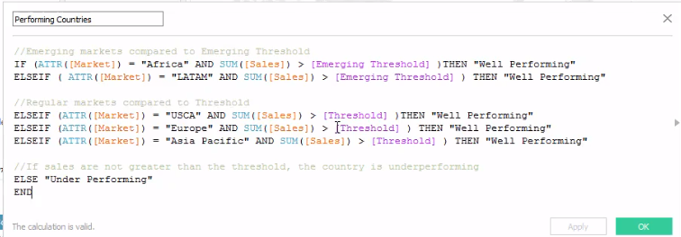

**STRING CALCULATIONS**

**BOOLEAN CALCULATION**

This calculated field determines if the parameter name is somewhere in the Product name field. Company is the name of our parameter. This creates a T/F Boolean. By using the parameter inside the calculated field we are able to zoom in on just the Products we choose

CONTAINS([Product Name], [**Company**])

**NUMBER CALCULATIONS**

This will allow us to see zeros instead of **NULLS**

Corrected Measure

ZN([Measure Name])

**TYPE CONVERSION FUNCTIONS**

This converts an integer into a string and then determines the lenth

LEN(STR([PatientID]) )

**AGE in years**

Wrap in INT type conversion to get whole numbers and not decimals

INT(DATEDIFF(‘day’, [Birthday], Today() ) / 365)

**LOD**

**INCLUDE and EXCLUDE** (will always result in a Measure)

**FIXED** (Can result in a Measure or Dimension)

* Dimension
  + String
  + Boolean
  + Date
* Measure
  + Number

**INCLUDE**

**Sum profit to the OrderID LOD**

{ INCLUDE [OrderID] : SUM([Profit]) }

**Fixed**

{ FIXED [Facility Name],[Anesthesia Code], [Doctor Name], [Dateof Service]: COUNTD([Encounter Number])}

**Calculated Field w FIXED LOD**

Dimension Members Exceeding Threshold

{ SUM(

INT( {FIXED [Dimension Selected] : SUM( [Sales] ) >= [Enter a Threshold]

) }

**Latest Month Sales**

**Create calculated field with a LOD MAX**

IF

DATEDIFF(‘month’, DATETRUNC(‘month’, [Order Date]),

{MAX(DATETRUNC(‘month’, [Order Date])) } )=0

THEN [Total Sales]

END

**CALCULATED FIELDS USING PARAMETERS**

**First create Level of Detail Parameter List**

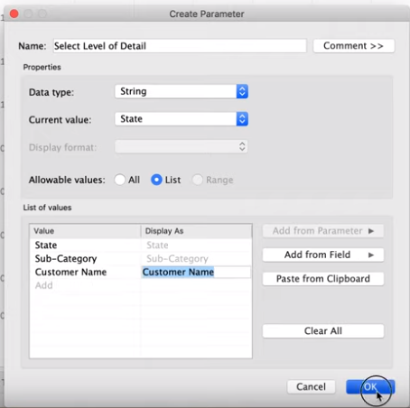

**CASE** [Select Level of Detail] 🡨 (parameter name goes here)

**WHEN** ‘State’ THEN [State]

**WHEN** ‘Sub-Category’ THEN [Sub-Category]

**WHEN** ‘Customer Name’ THEN [Customer Name]

**END**

**/** These calculated field w parameter will allow you to color code customers above and below threshold if you place it on color **/**

Above or Below Threshold

SUM([Sales]) >= [**Enter Sales Threshold**]

/********************************************/

SUM([Sales]) >= [**Enter Sales Threshold**]

AND

SUM(Discount]) >= [**Enter Discount Threshold**]